|  |  |
| --- | --- |
| Godox QS400II Flash  Đèn Flash Godox QS400II   Đèn Godox QS400II  Đèn Godox QS400II -3 Đèn Godox QS400II -1 Đèn Godox QS400II -3 | **Featured information:**  X1, FT-16, XT16 transmitter optional  Color temperature 5600K  Light recovery time is from 0.3 - 1.5 seconds  Flash duration: 1/800 to 1/2000 second  Price : $ 150  **Specifications:**  Weight  2.75 kg  Mount  -  Off-Camera Terminal  -  Size  26.0 x 14.0 x 41.0 cm (Including lid and handle)  [Flash light]  GN index  65 m at ISO 100  Bounce Head  -  Coverage  -  Swivel Head  -  Flash Duration  1/2000 to 1/800 second  Recycling time  0.3 to 1.5 seconds |

**Overview:**

The Godox QS400II is a balanced flash that provides light as natural as daylight. The lamp has a color temperature of 5600K and can adjust the light from 5-100% with professional and convenient features, providing the best light source when shooting. The 6.0 lb QS400II makes it easy to assemble accessories, and the Bowens mount is compatible with a variety of devices.

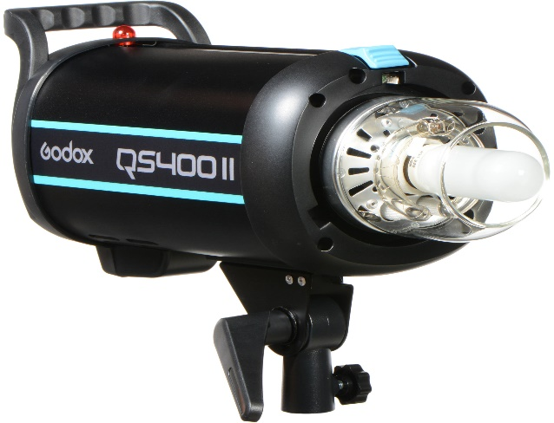

The Godox QS400II uses the TTL X1 wireless trigger and the XT16 and FT16 remote controllers to control power, lighting, and lamp activation. With the remote controller, you can control the lights easily. Besides, the light also integrates 32 channels and 16 groups to limit interference from other devices.

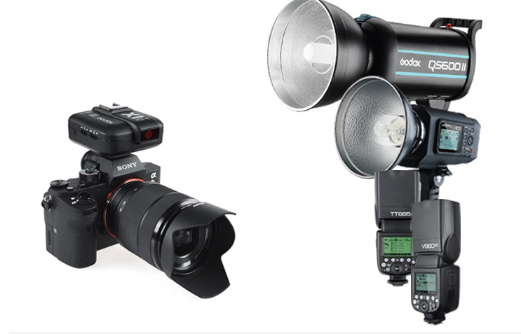

Most lights in the QSII series, including the Godox QS400II, have a quick recovery time of 0.3 to 1.5 seconds and a flash duration of 1/800 to 1/2000 seconds to help illuminate your subject continuously, so you don't miss it. any moment. The light head has an anti-flash function to help you easily work with cameras that use flash.

